Please join us for our Third Motorcycle Ride benefitting the ASHE Pittsburgh Scholarship Fund. You do not have to be an ASHE member to join us for this ride. You ARE required to sign a waiver though which is included with the registration.
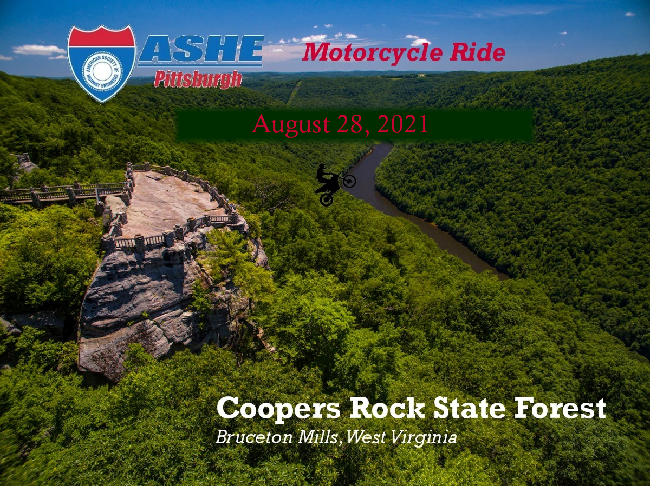
Registration is open for the 2021 ASHE PITTSBURGH SCHOLARSHIP MOTORCYCLE RIDE. Registration information and route details are included below. We look forward to seeing you there!
Our meeting point will be at the new Sheetz near PennDOT District 11-0 at 1297 Washington Pike, Bridgeville PA. We will meet at 9am.
We will take SR 0519 through the Southern Beltway project until we hit historic PA-40 which includes Scenery Hill.
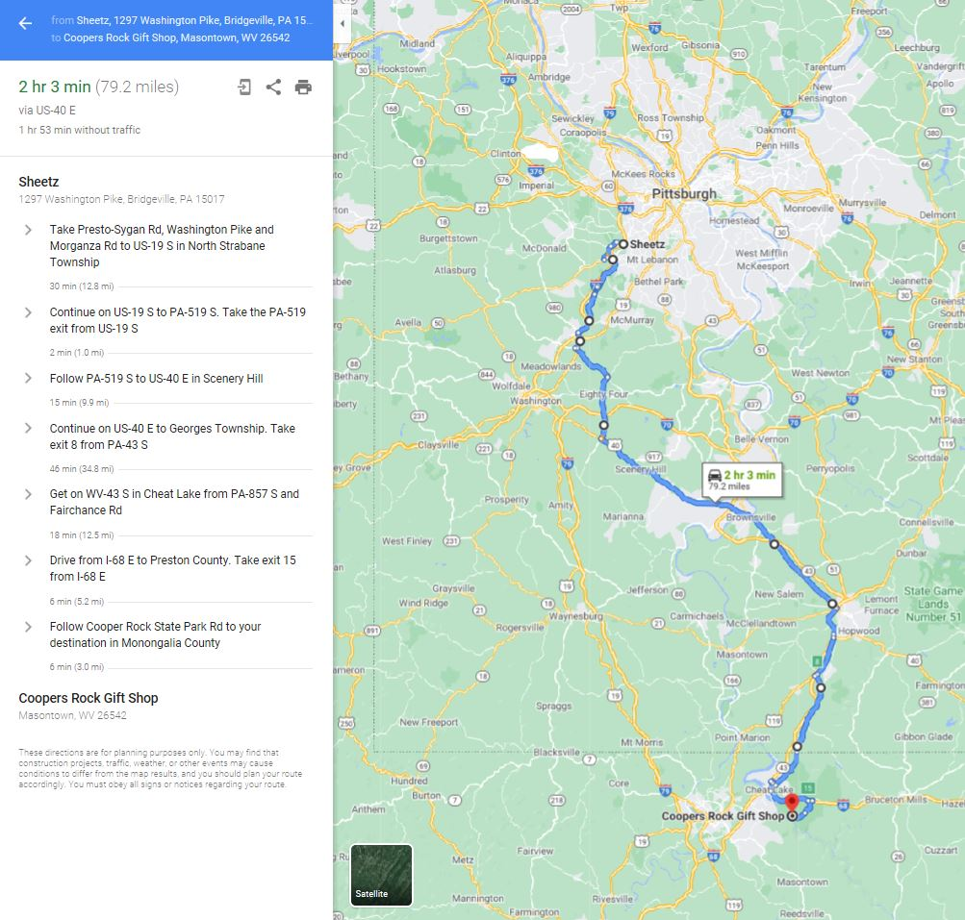
We will stop at Coopers Rock to take in the sights and get a group photo before heading to lunch at the Dockside Grill at nearby Cheat Lake.

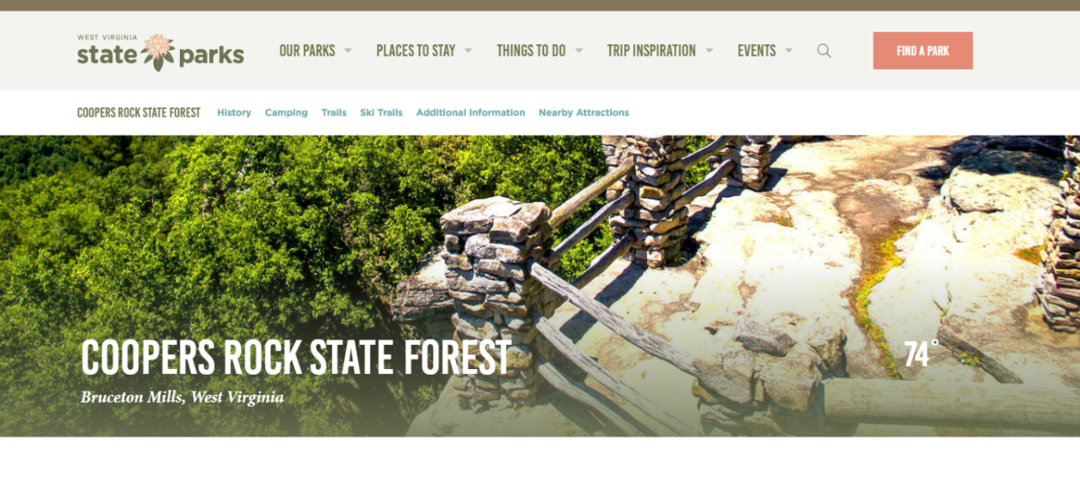
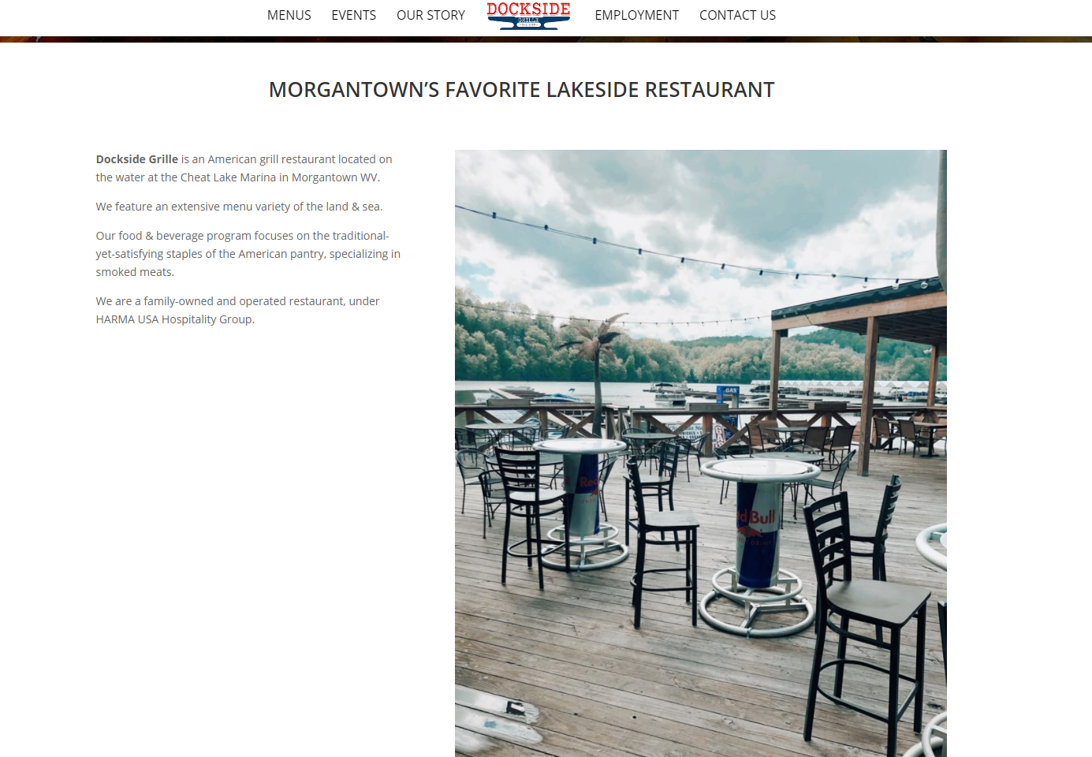
After lunch we have some options for the return trip.

Bring your ezpass with you if you would like to take PA43 home. We will have a group take PA978 to SR 51 to SR 88. If you have to get home quickly I-79 is nearby.
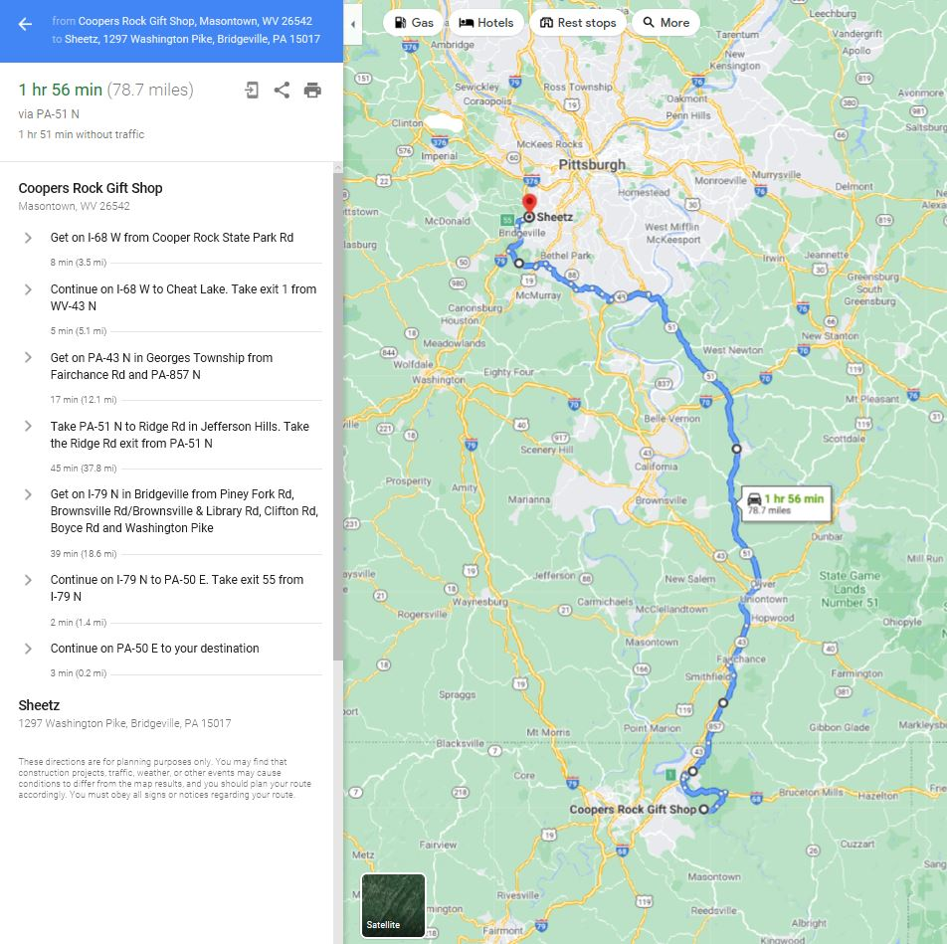

Registration is $25…please email Chuck Nash with any questions at cnash@msconsultants.com
Thanks and Ride Safe!

